B.K. Jewellers

**Function Requirement Specification (FRS)**

**Document for**

**“Sales management” department.**

Document NO: 001

Date: 07-02-2020

Prepared by:

Group 2

* **Revision History**

|  |  |  |  |
| --- | --- | --- | --- |
| **Revision Number** | **Revision Date** | **Summary of changes** | **Author** |
| **1** | 07/02/2020 | Document made. | Ghanshyam gamit |
| **2** | 18/04/2020 | * **Table of content:** Page numbers added. * (**2.1 &2.2 IMAGE**)**:** Indicators added. * **(2.1 &2.2 all elements):** Button state (active) added. | Rudra soni |
| **3** | 30/04/2020 | * **Table of content:** new items added. * **(2.1):** new wireframe added and explained. | Rudra soni |
| **4** | 04/05/2020 | * **(2.1):** new wireframes added and explained. | Rudra soni |
| **5** |  |  |  |
|  |  |  |  |

* **Table of Contents** -

|  |  |  |
| --- | --- | --- |
| Sr.  No. | Content | Page  No. |
| 1. | Introduction |  |
|  | * 1. Objective | 4 |
|  | 1.2 Scope | 4 |
|  |  |  |
| 2. | Functional Description |  |
|  | 2.1 Salesman | 4 |
|  | 2.1.1 Homepage | 4 |
|  | 2.1.2 New sale | 8 |
|  | 2.2 Sales manager | 16 |
|  |  |  |
|  |  |  |
| 3. | System hardware | 20 |
|  |  |  |
| 4. | Security | 20 |
|  |  |  |
| 5. | Regulatory requirement |  |
|  | 5.1 Accurate record generation | 20 |
|  | 5.2 Timeouts | 21 |
|  | 5.3 Operational system checks | 21 |
|  | 5.4 Electronic signature manifestation | 21 |
|  | 5.5 User password controls | 21 |
|  | 5.5.1 Password expiration | 21 |
|  | 5.6 Additional system controls | 22 |
|  | 5.6.1 Event logging | 22 |
|  | 5.6.2 System access | 22 |
|  | 5.6.3 Input checks | 22 |

1. **Introduction**
   1. Objective:

This is the functional requirement specification (FRS now onwards) for “Sales” functionalities used by sales department of **B.K. Jewellers.**

The FRS is details the capabilities and functions that the software must be capable of and reliably perform functionalities.

* 1. Scope:

This document applies to the “Sales department” of software. The document will address the functions of “Sales department” must be able to successfully perform primary business requirements. The focus is on what the “Sales department” must do.

1. **Function description**
   1. Salesman

J

I

H

G

* + 1. Homepage

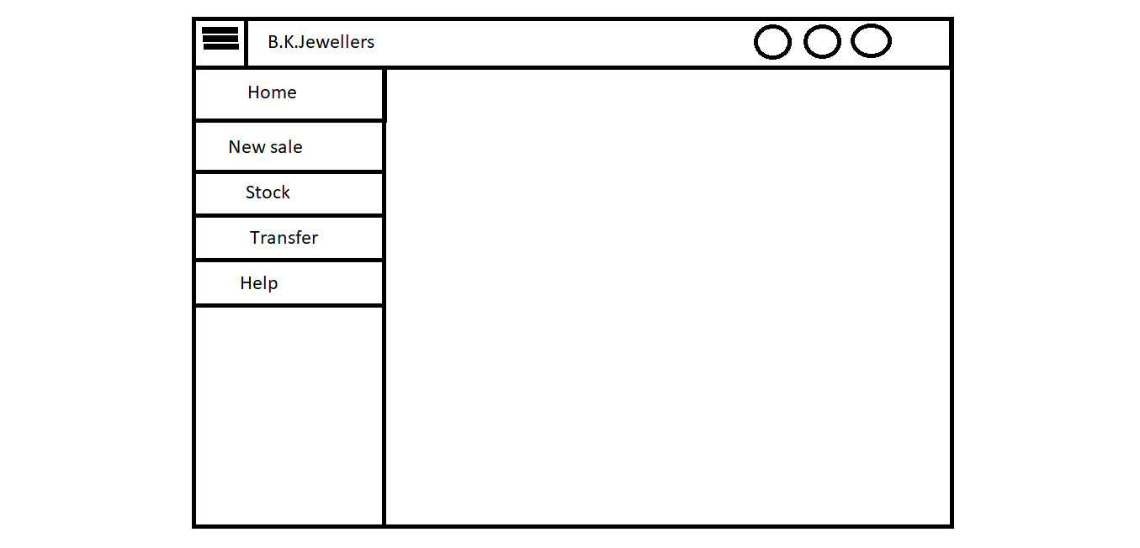

F

E

D

C

B

A

1. **Toggler:**

* Type: button.
* Text on button: toggle icon(3 strips).
* Use: It is used to toggle side menu.
* Events:

Click:- When user click on button the sidebar menu will be shrink to width of button.

Hover:- When user hover on button cursor changes to pointer.

* Function:
* When user clicks on the button, width of sidebar menu will shrink to the width of button therefore it looks like strip on left side.

1. **Home:**

* Type: button.
* Text on button: Home.
* Background color(Active): gray
* Use: to navigate on home page.
* Events:

click:- navigate user to the homepage.

Hover:- display information (text) “Home.” below mouse arrow.

* Functions:
* When button is clicked user will navigate to the page for creating new invoice

1. **New sale:**

* Type: button
* Text on button: New sale
* Background color(Active): gray
* Use: to create a new sale invoice.
* Events:

click:- navigate user to page for creating new invoices.

Hover:- display information (text) “new invoice.” below mouse arrow.

* Functions:
* When button is clicked user will navigate to the page for creating new invoice.

1. **Stock:**

* Type: button
* Text on button: Stock
* Background color (Active): gray
* Use: used for daily scanning of stock.
* Events:

click:- navigate user to a new window which contains two columns, one is full of available stock list and other is empty which is used for counting.

Hover:- display information (text) “daily stock scanning.” below mouse arrow.

* Functions:
* When clicked user will navigate to a new window which contains two columns side by side, one is full of available stock list and other is empty which is used for counting.

1. **Transfer:**

* Type: button
* Text on button: Transfer
* Background color(Active): gray
* Use: to change location of item.
* Events:

click:- navigate user to the page for location transfer.

Hover:- display information (text) “location transfer.” below mouse arrow.

* Functions:
* Automatic new voucher number will be generated.
* When button is clicked user will navigate to page for location transfer.

1. **Help**

* Type: button
* Text on button: Help
* Background color(Active): gray
* Use: to acknowledge the user.
* Events:

click:- a help page (source: help.docx)will appear which contains all information of every single step.

Hover:- display information (text) “help.” below mouse arrow.

* Functions:
* When button is clicked help.docx page will appear in full window.

1. **B.K.Jewellers:**

* Type: text.
* Use: only for decoration.
* Events: none.
* Functions: none.

1. **Search:**

* Type: button
* Text on button: search icon.
* Border Shape: circle.
* Use: used to search any invoice by its number.
* Events:

Click:- When user click on button search bar appears.

Hover:- When user hover on button cursor changes to pointer.

* Function:
* When clicked an input field appears at the place of button to search saved invoices.
* If entered invoice number is found, then data will appear in defined format.
* If entered invoice number is not found, an alert message appears with “Invoice not found!!” text.

1. **Notification:**

* Type: button
* Text on button: notification (bell) icon.
* Border Shape: circle.
* Use: used to view any notification from administration.
* Events:

Click:- When user click on button list of notification appears in small box at bottom of button.

Hover:- When user hover on button cursor changes to pointer.

* Function:
* When clicked a box containing notification appears at bottom of the button.
* If any notification is there, it will appear in list form in box.
* If there is no any notification, box will appear with message of “Nothing to see!” in it with light colour text.

1. **User indicator:**

* Type: button
* Text on button: user icon.
* Border Shape: circle.
* Use: used to display user which is login to software.
* Events:

Hover:- When user hover on button a tooltip appears at bottom with username which is login to software.

* Function:
* It saves username which is used to log in software and show it when user hovers on it in the form of tooltip.
  + 1. **New sale:**

f

e

b

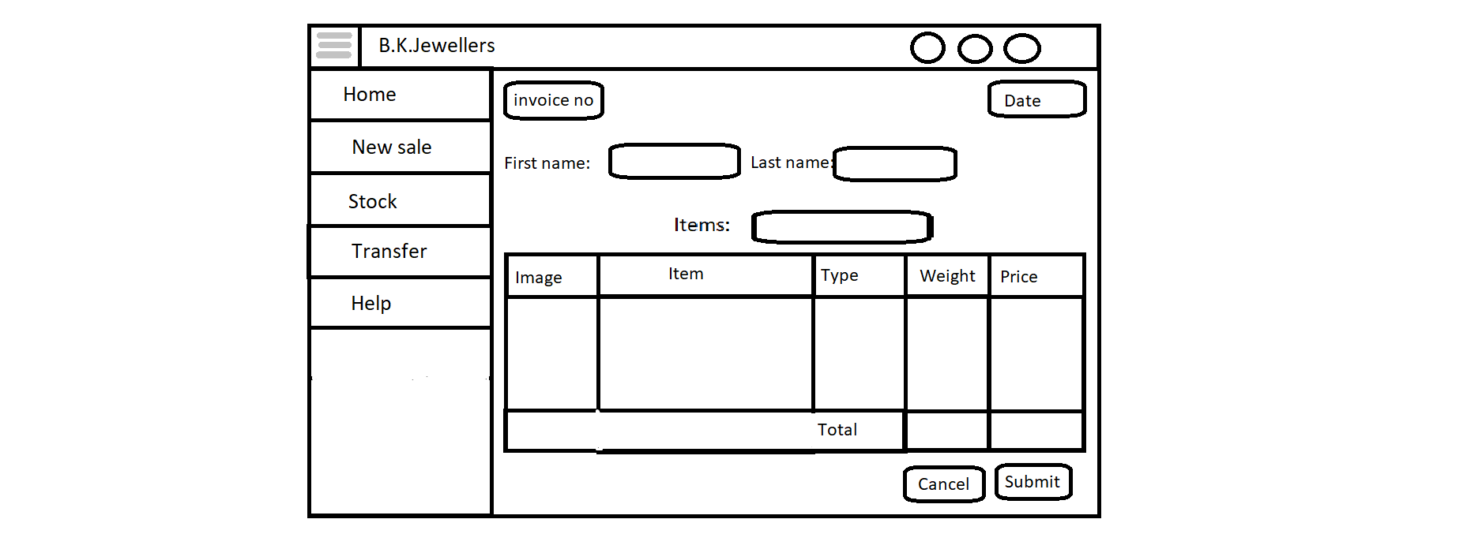

j

i

h

g

d

c

a

l

k

1. **Toggler:**

* Type: button.
* Text on button: toggle icon(3 strips).
* Use: It is used to toggle side menu.
* Events:

Click:- When user click on button the sidebar menu will be shrink to width of button.

Hover:- When user hover on button cursor changes to pointer.

* Function:
* When user clicks on the button, width of sidebar menu will shrink to the width of button therefore it looks like strip on left side.

1. **Invoice number indicator:**

* Type: input box.
* Information: Invoice number.
* Appearance: Highlighted and like a button with some border.
* Use: to show invoice number.
* Limitations: user can’t give input, user can’t select text.
* Events:

Hover:- When user hover on button cursor changes to pointer.

* Functions:
* Software check the invoice number from previously saved one in database and give one increment in the number and show it as new.
* Process will be repeated every time when user comes on this page for generating invoice.
* If invoice is not submitted, the process of generating new number will goes false and the number will not be saved.

1. **Date:**

* Type: input box.
* Information: current date.
* Appearance: Highlighted and like a button with some border.
* Use: to show current date.
* Limitation: user can’t give input, user can’t select text.
* Events:

Hover:- When user hover on button cursor changes to pointer.

* Functions:
* Scan current date and copy it in “dd/mm/yyyy” format.
* Process will be repeated every time when user comes on this page for generating invoice.

1. **First name:**

* Type: text.
* Information: First name.
* Appearance: bold.
* Use: to indicate purpose of input field.
* Events: none.
* Function: none.

1. **Input field:**

* Type: input field.
* Information: First name as placeholder.
* Appearance: bordered box with shadow.
* Use: to enter first name of client.
* Events:

Click:- When user click on it style changes.

* Function:
* On focus border will be highlighted from left.
* Saves value to server when invoice is submitted.

1. **Last name:**

* Type: text.
* Information: Last name.
* Appearance: bold.
* Use: to indicate purpose of input field.
* Events: none.
* Function: none.

1. **Input field:**

* Type: input field.
* Information: Last name as placeholder.
* Appearance: bordered box with shadow.
* Use: to enter last name of client.
* Events:

Click:- When user click on it style changes.

* Function:
* On focus border will be highlighted from left.
* Saves value to server when invoice is submitted.

1. **Item:**

* Type: text.
* Information: Item.
* Appearance: bold.
* Use: to indicate purpose of input field.
* Events: none.
* Function: none.

1. **Input field:**

* Type: input field.
* Information: Items as placeholder.
* Appearance: bordered box with shadow.
* Use: to add items for invoice.
* Limitations: input accepted only by barcode scanning.
* Events:

Click:- When user click on it style changes to indicate active state.

* Function:
* On focus border will be highlighted from left.
* When clicked barcode scanner activated for scanning and table for displaying values of items will get inputs from this.

1. **Table:**

* Type: table.
* Information of headings: Images, Item, Type, Weight and Price.
* Appearance:
* 5 columns and rows (scrollable if items are more except first and last).
* Headings are bolder and have different background colour.
* Last row containing 3 columns for addition of weight and price.
* Limitations: input accepted only by barcode scanning.
* Use: display scanned items.
* Events: none.
* Function:
* Input from barcode scanned in **input field at (i)**, and find the relative information of that item from database for example: image, weight, etc.
* Display the information in respective columns.
* Addition of all vales of **weight** and **price** done at last row.
* Addition of GST values to **price**.

1. **Cancel button:**

* Type: button.
* Text on button: Cancel
* Appearance: red bordered with same font colour.
* Use: cancel the current generated invoice.
* Event:

Click:- When user click on it deletion of all work done on current invoice.

Hover:- When user hover on it style get changed.

* Function:
* When user hover on button background colour changes to red and font becomes white.
* When clicked all process goes false and it deletes all work done on current invoice.
* When invoice get cancelled user will navigate to home page.

1. **Submit button:**

* Type: button.
* Text on button: Submit
* Appearance: green bordered with same font colour.
* Use: submits the current generated invoice.
* Event:

Click:- When user click on it new invoice get registered.

Hover:- When user hover on it style get changed.

* Function:
* When user hover on button background colour changes to green and font becomes white.
* When user click on button all processes become true.
* Scanned items get removed from stock of respective branch.
* User will navigate to new page which shows preview of generated invoice in predefined format for printing invoices
  + 1. **Stock**

b

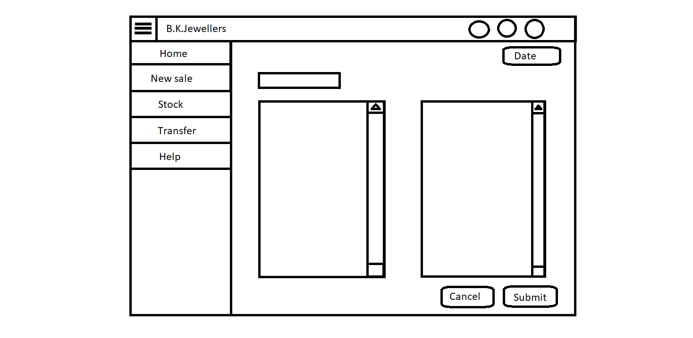

f

e

d

c

a

1. **Date indicator:**

* Type: input box.
* Information: current date.
* Appearance: Highlighted and like a button with some border.
* Use: to show current date.
* Limitation: user can’t give input, user can’t select text.
* Events:

Hover:- When user hover on button cursor changes to pointer.

* Functions:
* Scan current date and copy it in “dd/mm/yyyy” format.
* Process will be repeated every time when user comes on this page for generating invoice.

1. **Input field:**

* Type: input field.
* Placeholder: start scanning.
* Appearance: bordered box with shadow.
* Use: to enter scanned code.
* Events:

Click:- When user click text-area activated and barcode scanner starts functioning.

* Functions:
* When user click on it, text-area containing list of stock get selected to do tasks.
* When a barcode scanned, software will search the matching code and removes from particular text-area and add to another text-area for completed scanning items besides to it.
* If scanner fails to scan barcodes, scanning stops at that particular instance.

1. **Text-area:**

* Type: text-area.
* Information: list of all items at particular branch.
* Appearance: vertical text-area with vertical scroll bar.
* Use: to display available stock(not scanned).
* Limitation: user can’t resize it and can’t select items from it.
* Events: scroll bar get deactivated when content (list) is perfectly fits in the text-area.
* Functions:
* When software can’t able to find the particular code, it will show an alert with message **“Item not fond, contact administration!!”** in it.

1. **Text-area:**

* Type: text-area.
* Information: list of all scanned items.
* Appearance: vertical text-area with vertical scroll bar.
* Use: to display scanned stock.
* Limitation: user can’t resize it and can’t select items from it.
* Events: scroll bar get activated when content (list) can’t fit in the text-area.
* Functions:
* When scanning of a particular barcode get completed, that item will be added here.

1. **Cancel button:**

* Type: button.
* Text on button: Cancel
* Appearance: red bordered with same font colour.
* Use: cancel the current generated invoice.
* Event:

Click:- When user click on it deletion of all work done on current invoice.

Hover:- When user hover on it style get changed.

* Function:
* When user hover on button background colour changes to red and font becomes white.
* When clicked all process goes false and it deletes all work done on current invoice.
* When invoice get cancelled user will navigate to home page.

1. **Submit button:**

* Type: button.
* Text on button: Submit
* Appearance: green bordered with same font colour.
* Use: submits the current generated invoice.
* Event:

Click:- When user click on it new invoice get registered.

Hover:- When user hover on it style get changed.

* Function:
* When user hover on button background colour changes to green and font becomes white.
* When user click on button all processes become true.
* Scanned items get removed from stock of respective branch.
* User will navigate to new page which shows preview of generated invoice in predefined format for printing invoices
  + 1. **Transfer**

f

e

d

c

a

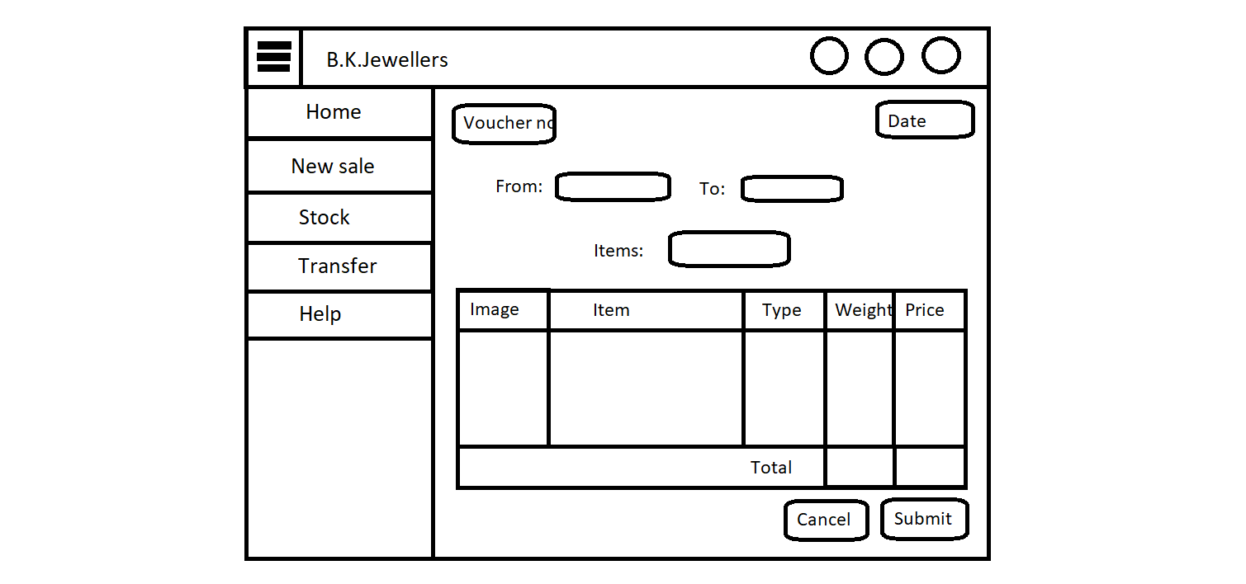

i

h

g

b

k

j

1. **Voucher number indicator:**

* Type: input box.
* Information: Voucher number.
* Appearance: Highlighted and like a button with some border.
* Use: to show invoice number.
* Limitations: user can’t give input, user can’t select text.
* Events:

Hover:- When user hover on button cursor changes to pointer.

* Functions:
* Software check the voucher number from previously saved one in database and give one increment in the number and show it as new.
* Process will be repeated every time when user comes on this page for generating voucher.
* If voucher is not submitted, the process of generating new number will goes false and the number will not be saved.

1. **Date indicator:**

* Type: input box.
* Information: current date.
* Appearance: Highlighted and like a button with some border.
* Use: to show current date.
* Limitation: user can’t give input, user can’t select text.
* Events:

Hover:- When user hover on button cursor changes to pointer.

* Functions:
* Scan current date and copy it in “dd/mm/yyyy” format.
* Process will be repeated every time when user comes on this page for generating invoice.

1. **From:**

* Type: text.
* Information: From.
* Appearance: bold.
* Use: to indicate purpose of input field.
* Events: none.
* Function: none.

1. **Input field:**

* Type: input field.
* Information: Sender’s location as placeholder.
* Appearance: bordered box with shadow.
* Use: to enter first name of client.
* Events:

Click:- When user click on it style changes.

* Function:
* On focus border will be highlighted from left.
* Saves value to server when invoice is submitted.

1. **To:**

* Type: text.
* Information: To.
* Appearance: bold.
* Use: to indicate purpose of input field.
* Events: none.
* Function: none.

1. **Input field:**

* Type: input field.
* Information: Receiver’s location as placeholder.
* Appearance: bordered box with shadow.
* Use: to enter first name of client.
* Events:

Click:- When user click on it style changes.

* Function:
* On focus border will be highlighted from left.
* Saves value to server when invoice is submitted.

1. **Items:**

* Type: text.
* Information: Item.
* Appearance: bold.
* Use: to indicate purpose of input field.
* Events: none.
* Function: none.

1. **Input field:**

* Type: input field.
* Information: Items as placeholder.
* Appearance: bordered box with shadow.
* Use: to add items for invoice.
* Limitations: input accepted only by barcode scanning.
* Events:

Click:- When user click on it style changes to indicate active state.

* Function:
* On focus border will be highlighted from left.
* When clicked barcode scanner activated for scanning and table for displaying values of items will get inputs from this.

1. **Table:**

* Type: table.
* Information of headings: Images, Item, Type, Weight and Price.
* Appearance:
* 5 columns and rows (scrollable if items are more except first and last).
* Headings are bolder and have different background colour.
* Last row containing 3 columns for addition of weight and price.
* Limitations: input accepted only by barcode scanning.
* Use: display scanned items.
* Events: none.
* Function:
* Input from barcode scanned in **input field at (i)**, and find the relative information of that item from database for example: image, weight, etc.
* Display the information in respective columns.
* Addition of all vales of **weight** and **price** done at last row.
* Addition of GST values to **price**.

1. **Cancel button:**

* Type: button.
* Text on button: Cancel
* Appearance: red bordered with same font colour.
* Use: cancel the current generated invoice.
* Event:

Click:- When user click on it deletion of all work done on current invoice.

Hover:- When user hover on it style get changed.

* Function:
* When user hover on button background colour changes to red and font becomes white.
* When clicked all process goes false and it deletes all work done on current invoice.
* When invoice get cancelled user will navigate to home page.

1. **Submit button:**

* Type: button.
* Text on button: Submit
* Appearance: green bordered with same font colour.
* Use: submits the current generated invoice.
* Event:

Click:- When user click on it new invoice get registered.

Hover:- When user hover on it style get changed.

* Function:
* When user hover on button background colour changes to green and font becomes white.
* When user click on button all processes become true.
* Scanned items get removed from stock of respective branch.
* User will navigate to new page which shows preview of generated invoice in predefined format for printing invoices
  + 1. **Help**
  1. **Sales manager**
     1. **Homepage**

d

c

b

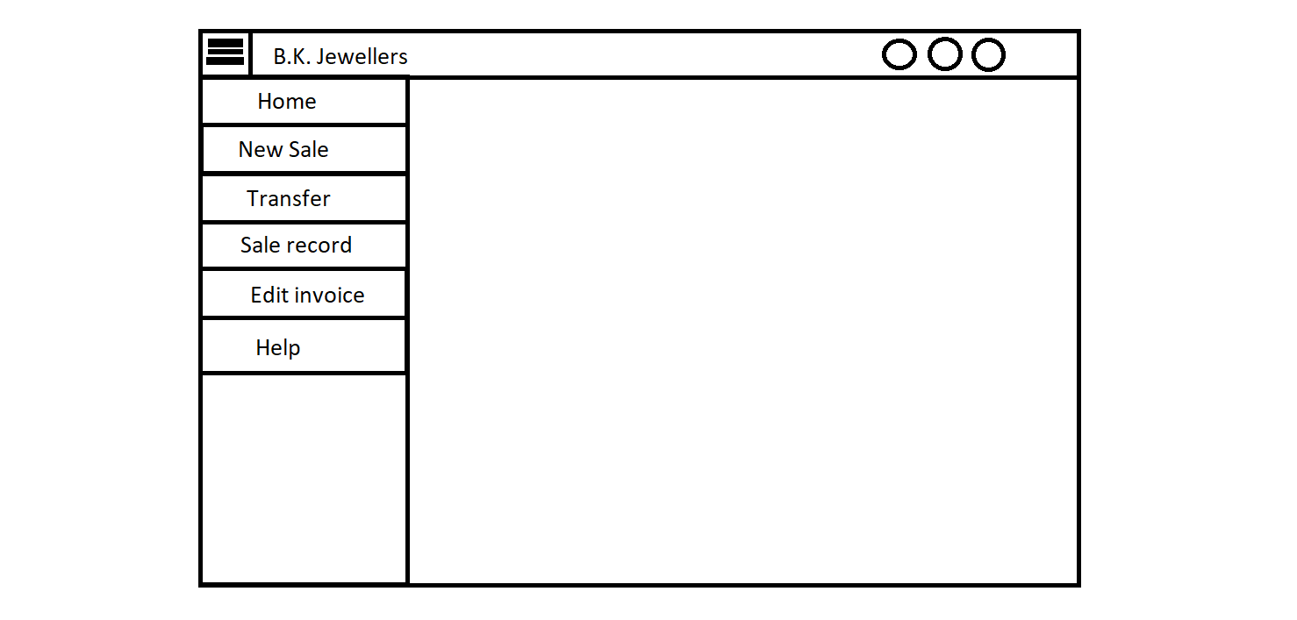

j

i

h

g

f

e

a

1. **Toggle:**

* Type: button.
* Text on button: toggle icon(3 strips).
* Use: It is used to toggle side menu.
* Events:

Click:- When user click on button the sidebar menu will be shrink to width of button.

Hover:- When user hover on button cursor changes to pointer.

* Function:
* When user clicks on the button, width of sidebar menu will shrink to the width of button therefore it looks like strip on left side.

1. **Search:**

* Type: button
* Text on button: search icon.
* Border Shape: circle.
* Use: used to search any invoice by its number.
* Events:

Click:- When user click on button search bar appears.

Hover:- When user hover on button cursor changes to pointer.

* Function:
* When clicked an input field appears at the place of button to search saved invoices.
* If entered invoice number is found, then data will appear in defined format.
* If entered invoice number is not found, an alert message appears with “Invoice not found!!” text.

1. **Notification:**

* Type: button
* Text on button: notification (bell) icon.
* Border Shape: circle.
* Use: used to view any notification from administration.
* Events:

Click:- When user click on button list of notification appears in small box at bottom of button.

Hover:- When user hover on button cursor changes to pointer.

* Function:
* When clicked a box containing notification appears at bottom of the button.
* If any notification is there, it will appear in list form in box.
* If there is no any notification, box will appear with message of “Nothing to see!” in it with light colour text

1. **User indicator:**

* Type: button
* Text on button: user icon.
* Border Shape: circle.
* Use: used to display user which is login to software.
* Events:

Hover:- When user hover on button a tooltip appears at bottom with username which is login to software.

* Function:
* It saves username which is used to log in software and show it when user hovers on it in the form of tooltip.

1. **Home:**

* Type: button.
* Text on button: Home.
* Background color(Active): gray
* Use: to navigate on home page.
* Events:

click:- navigate user to the homepage.

Hover:- display information (text) “Home.” below mouse arrow.

* Functions:
  + When button is clicked user will navigate to the Homepage.

1. **New sale:**

* Type: button
* Text on button: New sale
* Background color(Active): gray
* Use: to create a new sale invoice.
* Events:

click:- navigate user to page for creating new invoices.

Hover:- display information (text) “new invoice.” below mouse arrow.

* Functions:
* When button is clicked user will navigate to the page for creating new invoice.

1. **Transfer:**

* Type: button
* Text on button: Transfer
* Background color(Active): gray
* Use: to change location of item.
* Events:

click:- navigate user to the page for location transfer.

Hover:- display information (text) “location transfer.” below mouse arrow.

* Functions:
* Automatic new voucher number will be generated.
* When button is clicked user will navigate to page for location transfer.

1. **Sale record:**

* Type: Type: button
* Text on button: Sale record
* Background color(Active): gray
* Use: to view history of invoices.
* Events:

Click:

* When user clicks on button, he/she will navigate to window which contain list of submitted invoices in tabular form.

1. **Edit invoice:**

* Type: Type: button
* Text on button: Edit invoice.
* Background color(Active): gray
* Use: to edit or change submitted invoices.
* Events:

Click:

* When user click on button, he/she will navigate to window which contain search bar for invoice number and open invoice in editing mode.

1. **Help:**

* Type: button
* Text on button: Help
* Background color(Active): gray
* Use: to acknowledge the user.
* Events:

click:- a help page (source: help.docx)will appear which contains all information of every single step.

Hover:- display information (text) “help.” below mouse arrow.

* Functions:
* When button is clicked help.docx page will appear in full window.
  + 1. **New Sale**

f

e

b



j

i

h

g

d

c

a

l

k

1. **Toggle:**

* Type: button.
* Text on button: toggle icon(3 strips).
* Use: It is used to toggle side menu.
* Events:

Click:- When user click on button the sidebar menu will be shrink to width of button.

Hover:- When user hover on button cursor changes to pointer.

* Function:
* When user clicks on the button, width of sidebar menu will shrink to the width of button therefore it looks like strip on left side.

1. **Invoice number indicator:**

* Type: input box.
* Information: Invoice number.
* Appearance: Highlighted and like a button with some border.
* Use: to show invoice number.
* Limitations: user can’t give input, user can’t select text.
* Events:

Hover:- When user hover on button cursor changes to pointer.

* Functions:
* Software check the invoice number from previously saved one in database and give one increment in the number and show it as new.
* Process will be repeated every time when user comes on this page for generating invoice.
* If invoice is not submitted, the process of generating new number will goes false and the number will not be saved.

1. **Date indicator:**

* Type: input box.
* Information: current date.
* Appearance: Highlighted and like a button with some border.
* Use: to show current date.
* Limitation: user can’t give input, user can’t select text.
* Events:

Hover:- When user hover on button cursor changes to pointer.

* Functions:
* Scan current date and copy it in “dd/mm/yyyy” format.
* Process will be repeated every time when user comes on this page for generating invoice.

1. **First name:**

* Type: text.
* Information: First name.
* Appearance: bold.
* Use: to indicate purpose of input field.
* Events: none.
* Function: none.

1. **Input field:**

* Type: input field.
* Information: First name as placeholder.
* Appearance: bordered box with shadow.
* Use: to enter first name of client.
* Events:

Click:- When user click on it style changes.

* Function:
* On focus border will be highlighted from left.
* Saves value to server when invoice is submitted.

1. **Last name:**

* Type: text.
* Information: Last name.
* Appearance: bold.
* Use: to indicate purpose of input field.
* Events: none.
* Function: none.

1. **Input field:**

* Type: input field.
* Information: Last name as placeholder.
* Appearance: bordered box with shadow.
* Use: to enter last name of client.
* Events:

Click:- When user click on it style changes.

* Function:
* On focus border will be highlighted from left.
* Saves value to server when invoice is submitted.

1. **Items:**

* Type: text.
* Information: Item.
* Appearance: bold.
* Use: to indicate purpose of input field.
* Events: none.
* Function: none.

1. **Input field:**

* Type: input field.
* Information: Items as placeholder.
* Appearance: bordered box with shadow.
* Use: to add items for invoice.
* Limitations: input accepted only by barcode scanning.
* Events:

Click:- When user click on it style changes to indicate active state.

* Function:
* On focus border will be highlighted from left.
* When clicked barcode scanner activated for scanning and table for displaying values of items will get inputs from this.

1. **Table:**

* Type: table.
* Information of headings: Images, Item, Type, Weight and Price.
* Appearance:
* 5 columns and rows (scrollable if items are more except first and last).
* Headings are bolder and have different background colour.
* Last row containing 3 columns for addition of weight and price.
* Limitations: input accepted only by barcode scanning.
* Use: display scanned items.
* Events: none.
* Function:
* Input from barcode scanned in **input field at (i)**, and find the relative information of that item from database for example: image, weight, etc.
* Display the information in respective columns.
* Addition of all vales of **weight** and **price** done at last row.
* Addition of GST values to **price**.

1. **Cancel button:**

* Type: button.
* Text on button: Cancel
* Appearance: red bordered with same font colour.
* Use: cancel the current generated invoice.
* Event:

Click:- When user click on it deletion of all work done on current invoice.

Hover:- When user hover on it style get changed.

* Function:
* When user hover on button background colour changes to red and font becomes white.
* When clicked all process goes false and it deletes all work done on current invoice.
* When invoice get cancelled user will navigate to home page.

1. **Submit button:**

* Type: button.
* Text on button: Submit
* Appearance: green bordered with same font colour.
* Use: submits the current generated invoice.
* Event:

Click:- When user click on it new invoice get registered.

Hover:- When user hover on it style get changed.

* Function:
* When user hover on button background colour changes to green and font becomes white.
* When user click on button all processes become true.
* Scanned items get removed from stock of respective branch.
* User will navigate to new page which shows preview of generated invoice in predefined format for printing invoices
  + 1. **Transfer**

f

e

d

c

a



h

g

b

i

j

k

1. **Invoice number indicator:**

* Type: input box.
* Information: Voucher number.
* Appearance: Highlighted and like a button with some border.
* Use: to show invoice number.
* Limitations: user can’t give input, user can’t select text.
* Events:

Hover:- When user hover on button cursor changes to pointer.

* Functions:
* Software check the voucher number from previously saved one in database and give one increment in the number and show it as new.
* Process will be repeated every time when user comes on this page for generating voucher.
* If voucher is not submitted, the process of generating new number will goes false and the number will not be saved.

1. **Date indicator:**

* Type: input box.
* Information: current date.
* Appearance: Highlighted and like a button with some border.
* Use: to show current date.
* Limitation: user can’t give input, user can’t select text.
* Events:

Hover:- When user hover on button cursor changes to pointer.

* Functions:
* Scan current date and copy it in “dd/mm/yyyy” format.
* Process will be repeated every time when user comes on this page for generating invoice.

1. **From:**

* Type: text.
* Information: From.
* Appearance: bold.
* Use: to indicate purpose of input field.
* Events: none.
* Function: none.

1. **Input field:**

* Type: input field.
* Information: Sender’s location as placeholder.
* Appearance: bordered box with shadow.
* Use: to enter first name of client.
* Events:

Click:- When user click on it style changes.

* Function:
* On focus border will be highlighted from left.
* Saves value to server when invoice is submitted.

1. **To:**

* Type: text.
* Information: To.
* Appearance: bold.
* Use: to indicate purpose of input field.
* Events: none.
* Function: none.

1. **Input field:**

* Type: input field.
* Information: Receiver’s location as placeholder.
* Appearance: bordered box with shadow.
* Use: to enter first name of client.
* Events:

Click:- When user click on it style changes.

* Function:
* On focus border will be highlighted from left.
* Saves value to server when invoice is submitted.

1. **Items:**

* Type: text.
* Information: Item.
* Appearance: bold.
* Use: to indicate purpose of input field.
* Events: none.
* Function: none.

1. **Input field:**

* Type: input field.
* Information: Items as placeholder.
* Appearance: bordered box with shadow.
* Use: to add items for invoice.
* Limitations: input accepted only by barcode scanning.
* Events:

Click:- When user click on it style changes to indicate active state.

* Function:
* On focus border will be highlighted from left.
* When clicked barcode scanner activated for scanning and table for displaying values of items will get inputs from this.

1. **Table:**

* Type: table.
* Information of headings: Images, Item, Type, Weight and Price.
* Appearance:
* 5 columns and rows (scrollable if items are more except first and last).
* Headings are bolder and have different background colour.
* Last row containing 3 columns for addition of weight and price.
* Limitations: input accepted only by barcode scanning.
* Use: display scanned items.
* Events: none.
* Function:
* Input from barcode scanned in **input field at (i)**, and find the relative information of that item from database for example: image, weight, etc.
* Display the information in respective columns.
* Addition of all vales of **weight** and **price** done at last row.
* Addition of GST values to **price**.

1. **Cancel button:**

* Type: button.
* Text on button: Cancel
* Appearance: red bordered with same font colour.
* Use: cancel the current generated invoice.
* Event:

Click:- When user click on it deletion of all work done on current invoice.

Hover:- When user hover on it style get changed.

* Function:
* When user hover on button background colour changes to red and font becomes white.
* When clicked all process goes false and it deletes all work done on current invoice.
* When invoice get cancelled user will navigate to home page.

1. **Submit button:**

* Type: button.
* Text on button: Submit
* Appearance: green bordered with same font colour.
* Use: submits the current generated invoice.
* Event:

Click:- When user click on it new invoice get registered.

Hover:- When user hover on it style get changed.

* Function:
* When user hover on button background colour changes to green and font becomes white.
* When user click on button all processes become true.
* Scanned items get removed from stock of respective branch.
* User will navigate to new page which shows preview of generated invoice in predefined format for printing invoices
  + 1. **Sale Record**

g

f

e

d

c

b

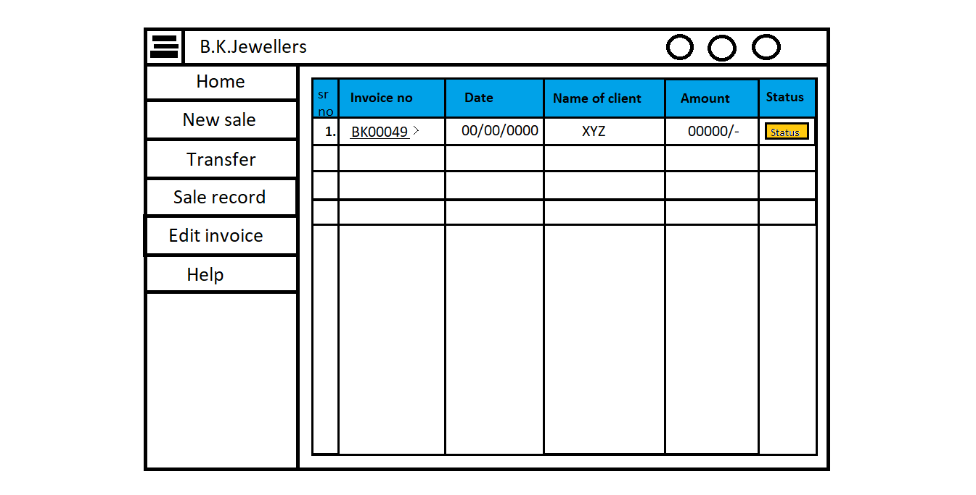

a

1. **Table:**

* Type: table.
* Appearance: contains 6 columns and header with some color.
* Use: to store the submitted invoices in effective way.
* Limitations: only 2nd and 6th columns have some functions, rest all are for only displaying information.
* Events: none.
* Functions: add all invoices which are submitted from all branches.

1. **1st column:**

* Use: for serial numbers.
* Header text: Sr. no.
* Events: none.
* Functions: when user submits an invoice, it will be automatically listed as new serial number.

1. **2nd column:**

* Use: to display invoice number.
* Header text: Invoice no.
* Data (*td*) type: link.
* Events:

Click: when user clicks on link, he/she will see the details of that particular invoice.

Hover: when user hover on it, style changes.

* Functions:
* When a user submits any invoice, software will scan that invoice number and put in here as a link.
* When user clicks on link, he/she will see the details of that particular invoice, in the same format of generating invoice (*Ref.: 2.2.2*).
* Limitation: viewer/user can not make any changes.

1. **3rd column:**

* Use: to indicate the submit date.
* Header text: Date.
* Events: none.
* Functions: software will scan the date from the invoice and put in this column for the history purpose and of providing effective information.

1. **4th column:**

* Use: to indicate the name of client.
* Header text: Name of client.
* Events: none.
* Functions: software will scan the name of client from the invoice and put in this column for the purpose of providing effective information.

1. **5th column:**

* Use: to indicate the total amount.
* Header text: Amount.
* Events: none.
* Functions: software will scan the amount from the invoice and put in this column for the purpose of providing effective information.

1. **6th column:**

* Use: to indicate the status of invoice.
* Header text: Status.
* Appearance: like button.
* Events: On click a dropdown opens.
* Functions:
* When user selects status from values given in dropdown software will save that value and display it in particular field.
* Values can be changeable anytime.
* Dropdown appearance:

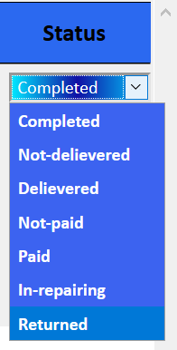

* + 1. **Edit Invoice**

a

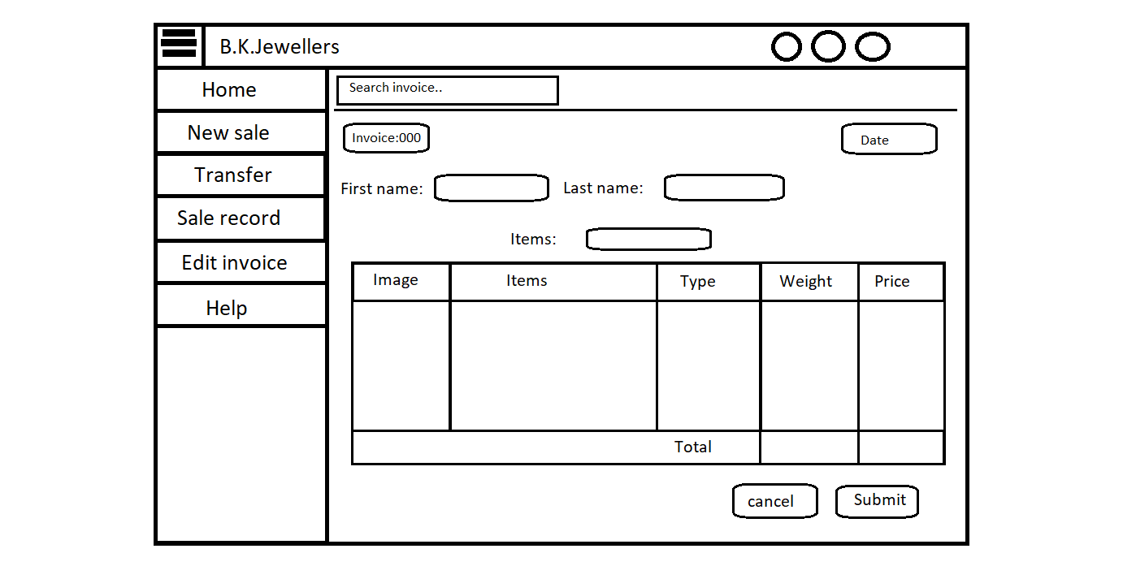

b

1. **Input field:**

* Type: input field.
* Appearance: search box.
* Placeholder: Search invoice..
* Use: to search invoices.
* Events: on click, activate the field.
* Functions: when user enter any invoice number, software will go and match with other which are saved in database.
* Error handling:
* If a match found, result (invoice) will display with editing enabled.
* If match not found, an error message will appear with “*Invoice not found!!, please check your invoice number again.*” Information.

1. **Editing an invoice:**

**Note: [Appearance and functionalities are same as generating invoice. *Ref(2.2.2)*]**

* Limitations: No new invoice number and date will be generated.
  + 1. **Help**

1. **System hardware**

The software can run on the minimum standard PC workstation or laptop configuration by **B.K. Jewellers.** This part can be accessible by all PC present in workgroup of organization for “Sales”.

This part of the software does not affect the organization LAN.

1. **Security description**

The sales part is only accessible through the software provided by “BlackSky Systems.” This software or any part of the software does not open from outside the configured environment of **B.K. Jewellers.**

1. **Regulatory requirements**
   1. Accurate record generation:

The functionality meets the following requirements:

* The ability to generate accurate and complete copies of record in both human readable and electronic form is suitable for inspection & review by the agency.
* Users are able to select search queries.
* Users are able to export data through MS Excel sheet.
  1. Timeouts:

The software for “Sales department” will not automatically time-out, it is supposed to run after login till the user logout from the system.

* 1. Operational system checks:

The “Sales department” software uses operational system checks for permitted sequencing of steps and events.

* 1. Electronic signature manifestation:

The software has secure data in system through electronic signatures. Data secured with an electronic signature cannot be edited or deleted unless the signature is removed.

* 1. User password controls:

This software does not allow user to change their passwords. Only the administration has this authority.

5.5.1 Password expiration:

Once the password is created it never expires unless user requested to change it.

* 1. Additional system controls:

5.6.1 Event logging:

It includes system login and logout, as well as attempts failures.

5.6.2 System access:

Access to software must be controlled by user access to the LAN controlled by system identification and password.

5.6.3 Input checks:

When appropriate entries may programmatically checked before being accepted by software.(for example, No negative values accepted for item price.)